Constructing Ellipse

Definition
# Source: AI Source: Provided by: [Data Path: Persons Table -> ID Column: 1, Name_En Column: Motasem Essam] -> From: [ChatGPT] on [7/25/2026]
An ellipse is a closed, smooth curve in which the sum of the distances from every point on the curve to two fixed points is constant.
The two fixed points are called the foci.
If the foci are $F_{1}$and $F_{2}$, then every point $P$on the ellipse satisfies:
$$\boxed{PF_{1}+PF_{2}=2a}$$
where $2a$is the length of the major axis.
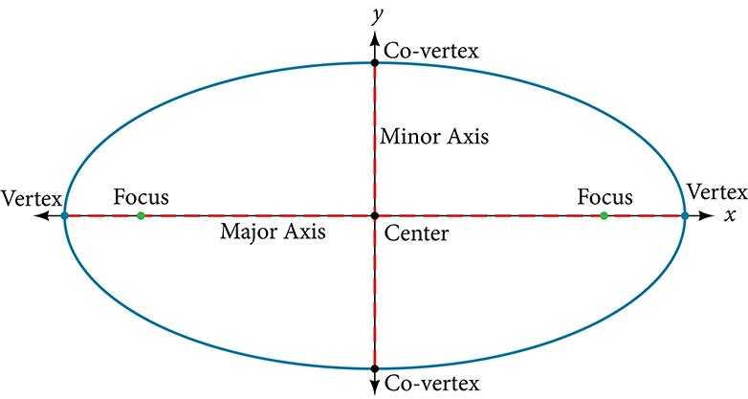
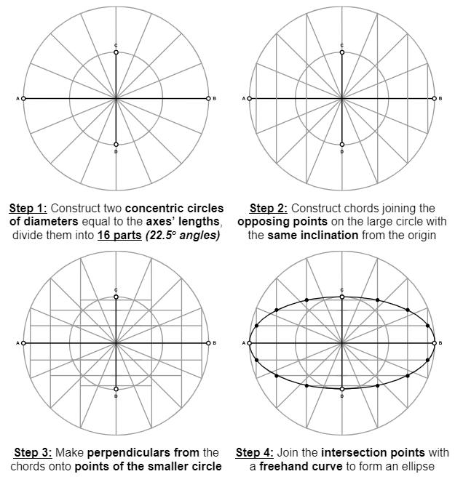
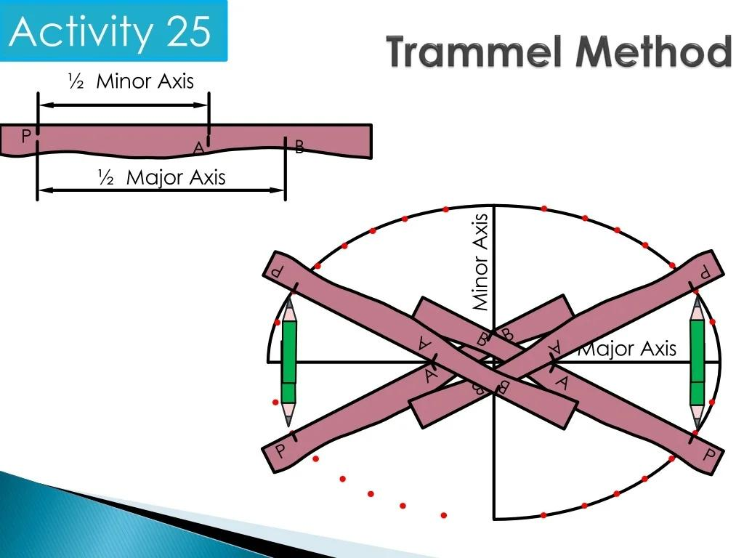
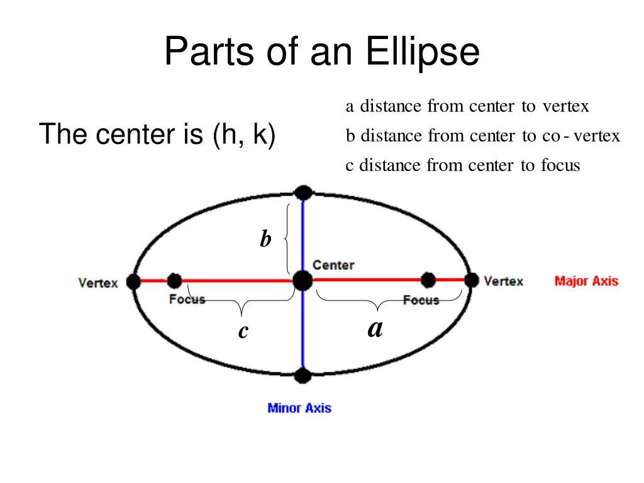

Fundamental Elements of an Ellipse
# Source: AI Source: Provided by: [Data Path: Persons Table -> ID Column: 1, Name_En Column: Motasem Essam] -> From: [ChatGPT] on [7/25/2026]
An ellipse has several important geometric elements.
Center
The midpoint of both axes is the center $O$.
Major Axis
The longest diameter of the ellipse is the major axis.
Its length is:
$$\boxed{2a}$$
Minor Axis
The shortest diameter perpendicular to the major axis is the minor axis.
Its length is:
$$\boxed{2b}$$
where:
$$a≥b>0$$
Vertices
The endpoints of the major axis are the major vertices.
They are commonly denoted:
$$A, A^{'}$$
The endpoints of the minor axis are the minor vertices:
$$B, B^{'}$$
Foci
The two fixed points inside the ellipse are:
$$F_{1}, F_{2}$$
Their distance from the center is:
$$\boxed{c}$$
where:
$$\boxed{c^{2}=a^{2}-b^{2}}$$
Therefore:
$$\boxed{c=\sqrt{a^{2}-b^{2}}}$$

Standard Equation
# Source: AI Source: Provided by: [Data Path: Persons Table -> ID Column: 1, Name_En Column: Motasem Essam] -> From: [ChatGPT] on [7/25/2026]
For an ellipse centered at the origin with its major axis along the $x$-axis:
$$\boxed{\frac{x^{2}}{a^{2}}+\frac{y^{2}}{b^{2}}=1}$$
where:
$$a≥b>0$$
If the center is $\left(h , k\right)$:
$$\boxed{\frac{{\left(x-h\right)}^{2}}{a^{2}}+\frac{{\left(y-k\right)}^{2}}{b^{2}}=1}$$

Fundamental Construction Principle
# Source: AI Source: Provided by: [Data Path: Persons Table -> ID Column: 1, Name_En Column: Motasem Essam] -> From: [ChatGPT] on [7/25/2026]
An ellipse can be constructed from its defining property:
$$\boxed{PF_{1}+PF_{2}=2a}$$
This means that if the positions of the two foci are known and a constant total distance is maintained, the possible positions of $P$form an ellipse.
This gives the classical foci-and-string construction.

Constructing an Ellipse Using Two Foci and a String
# Source: AI Source: Provided by: [Data Path: Persons Table -> ID Column: 1, Name_En Column: Motasem Essam] -> From: [ChatGPT] on [7/25/2026]
This is one of the simplest physical geometric constructions.
Given
- Two foci $F_{1}$and $F_{2}$.
- A fixed total length $2a$.
Steps
- Mark the two foci $F_{1}$and $F_{2}$.
- Prepare a string whose length is $2a$.
- Fix the two ends of the string at $F_{1}$and $F_{2}$.
- Keep the string stretched with a pencil or marking point $P$.
- Move $P$while maintaining tension in the string.
- Trace the resulting curve.
- Continue around the two foci until the curve is closed.
Every point satisfies:
$$PF_{1}+PF_{2}=2a$$
Therefore, the traced curve is an ellipse.

Constructing an Ellipse by the Foci-and-Points Method
# Source: AI Source: Provided by: [Data Path: Persons Table -> ID Column: 1, Name_En Column: Motasem Essam] -> From: [ChatGPT] on [7/25/2026]
A more formal construction can be performed without physically using a string.
Given
- Major axis $2a$.
- Foci $F_{1},F_{2}$.
Steps
- Construct the major axis.
- Locate the center $O$.
- Locate the foci $F_{1},F_{2}$.
- Choose a point $X$on the major axis between the center and a vertex.
- With center $F_{1}$and radius $AX$, draw an arc.
- With center $F_{2}$and radius $A^{'}X$, draw another arc.
- Their intersections give points on the ellipse.
- Repeat for several values of $X$.
- Reflect the constructed points across the major and minor axes.
- Draw a smooth curve through the points.
The radii satisfy:
$$\boxed{PF_{1}+PF_{2}=2a}$$

Constructing an Ellipse From Its Axes
# Source: AI Source: Provided by: [Data Path: Persons Table -> ID Column: 1, Name_En Column: Motasem Essam] -> From: [ChatGPT] on [7/25/2026]
If the major axis and minor axis are given, the ellipse can be constructed using geometric point methods.
Suppose:
$$AA^{'}=2a$$
and:
$$BB^{'}=2b$$
Steps
- Construct the major axis $AA^{'}$.
- Find its midpoint $O$.
- Through $O$, construct the perpendicular minor axis.
- Mark:
$$OB=OB^{'}=b$$
- Divide the appropriate portions of the major and minor axes into equal intervals.
- Through corresponding division points, construct horizontal and vertical lines.
- Use the intersections to locate points on the ellipse.
- Reflect the points across both axes.
- Draw a smooth curve through the resulting points.
This is commonly called a rectangle/grid method or oblong method, depending on the specific construction procedure.

Concentric Circles Method
# Source: AI Source: Provided by: [Data Path: Persons Table -> ID Column: 1, Name_En Column: Motasem Essam] -> From: [ChatGPT] on [7/25/2026]
Another graphical construction uses two concentric circles.
Given
- Major radius $a$.
- Minor radius $b$.
Steps
- Mark the center $O$.
- Draw a circle of radius $a$.
- Draw a second concentric circle of radius $b$.
- Divide the circles into corresponding angular positions.
- From points on the larger circle, draw lines parallel to the minor axis.
- From corresponding points on the smaller circle, draw lines parallel to the major axis.
- The intersections provide points on the ellipse.
- Repeat around the complete circles.
- Connect the points with a smooth curve.
The construction uses corresponding projections from the two circles.

Trammel Construction
# Source: AI Source: Provided by: [Data Path: Persons Table -> ID Column: 1, Name_En Column: Motasem Essam] -> From: [ChatGPT] on [7/25/2026]
The trammel method is a mechanical construction of an ellipse.
A rigid bar contains two marked points that slide along two perpendicular lines.
If:
- one marked point moves along the major-axis direction;
- the other moves along the minor-axis direction;
- a fixed point on the bar traces the curve;
the traced locus is an ellipse.
The method is also called the ellipsograph principle or trammel of Archimedes.

Constructing an Ellipse With a Trammel
# Source: AI Source: Provided by: [Data Path: Persons Table -> ID Column: 1, Name_En Column: Motasem Essam] -> From: [ChatGPT] on [7/25/2026]
Given
Major semi-axis:
$$a$$
Minor semi-axis:
$$b$$
Principle
A rigid bar is arranged so that its two reference points slide along perpendicular axes.
A tracing point is positioned according to the required distances.
As the bar moves while maintaining the constraints, the tracing point follows an elliptical path.
This method is particularly useful for practical drafting and mechanical construction.

Constructing an Ellipse From a Rectangle
# Source: AI Source: Provided by: [Data Path: Persons Table -> ID Column: 1, Name_En Column: Motasem Essam] -> From: [ChatGPT] on [7/25/2026]
An ellipse can also be approximated graphically from a rectangle containing the ellipse.
Given
- Rectangle width:
$$2a$$
- Rectangle height:
$$2b$$
Steps
- Construct a rectangle with dimensions $2a×2b$.
- Find its center.
- Draw the major and minor axes through the center.
- Divide selected sides into corresponding equal intervals.
- Draw construction lines between the corresponding points.
- Locate points through the resulting intersections.
- Repeat symmetrically in all four quadrants.
- Draw a smooth curve through the points.
This provides a practical approximation of the ellipse.

Types / Construction Situations
# Source: AI Source: Provided by: [Data Path: Persons Table -> ID Column: 1, Name_En Column: Motasem Essam] -> From: [ChatGPT] on [7/25/2026]
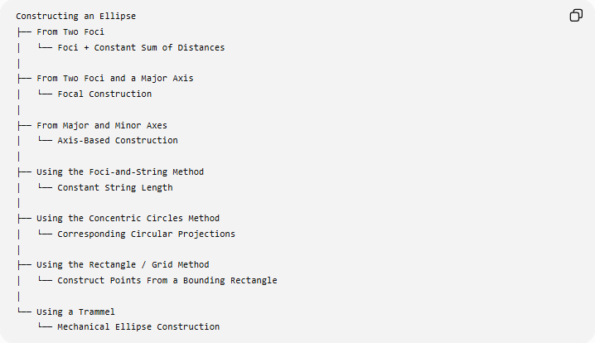
Constructing an Ellipse
├── From Two Foci
│ └── Foci + Constant Sum of Distances
│
├── From Two Foci and a Major Axis
│ └── Focal Construction
│
├── From Major and Minor Axes
│ └── Axis-Based Construction
│
├── Using the Foci-and-String Method
│ └── Constant String Length
│
├── Using the Concentric Circles Method
│ └── Corresponding Circular Projections
│
├── Using the Rectangle / Grid Method
│ └── Construct Points From a Bounding Rectangle
│
└── Using a Trammel
└── Mechanical Ellipse Construction
Classification note: these are different construction methods or construction situations, rather than different mathematical types of ellipses.

Basic Constructions Used
# Source: AI Source: Provided by: [Data Path: Persons Table -> ID Column: 1, Name_En Column: Motasem Essam] -> From: [ChatGPT] on [7/25/2026]
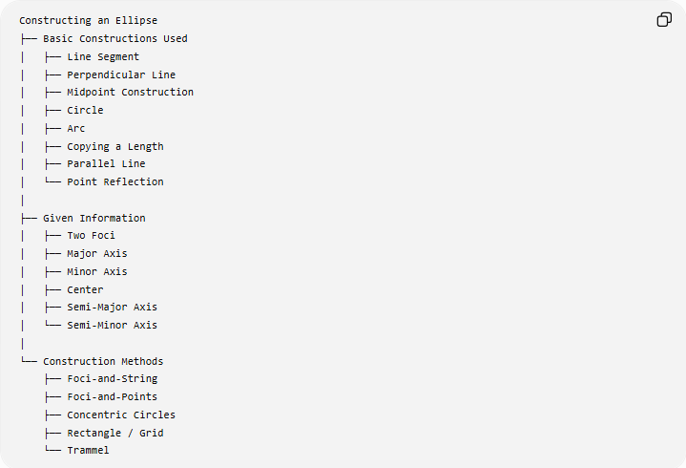
Constructing an Ellipse
├── Basic Constructions Used
│ ├── Line Segment
│ ├── Perpendicular Line
│ ├── Midpoint Construction
│ ├── Circle
│ ├── Arc
│ ├── Copying a Length
│ ├── Parallel Line
│ └── Point Reflection
│
├── Given Information
│ ├── Two Foci
│ ├── Major Axis
│ ├── Minor Axis
│ ├── Center
│ ├── Semi-Major Axis
│ └── Semi-Minor Axis
│
└── Construction Methods
├── Foci-and-String
├── Foci-and-Points
├── Concentric Circles
├── Rectangle / Grid
└── Trammel

Types of Ellipse by Axis Relationship
# Source: AI Source: Provided by: [Data Path: Persons Table -> ID Column: 1, Name_En Column: Motasem Essam] -> From: [ChatGPT] on [7/25/2026]
Although these are classifications of ellipses, rather than construction methods, they are useful when constructing one.
Circle
If:
$$a=b$$
then:
$$c=0$$
and the ellipse becomes a circle.
Thus:
$$\boxed{\text{Circle is a special case of an ellipse}}$$
in the analytic-geometry sense.

Non-Circular Ellipse
If:
$$a>b$$
the ellipse has two distinct foci and a longer major axis.
$$\boxed{c>0}$$

Horizontal and Vertical Ellipses
# Source: AI Source: Provided by: [Data Path: Persons Table -> ID Column: 1, Name_En Column: Motasem Essam] -> From: [ChatGPT] on [7/25/2026]
Horizontal Ellipse
If the major axis is horizontal:
$$\boxed{\frac{{\left(x-h\right)}^{2}}{a^{2}}+\frac{{\left(y-k\right)}^{2}}{b^{2}}=1}$$
with:
$$a>b$$
Vertical Ellipse
If the major axis is vertical:
$$\boxed{\frac{{\left(x-h\right)}^{2}}{b^{2}}+\frac{{\left(y-k\right)}^{2}}{a^{2}}=1}$$
with:
$$a>b$$

Important Properties
# Source: AI Source: Provided by: [Data Path: Persons Table -> ID Column: 1, Name_En Column: Motasem Essam] -> From: [ChatGPT] on [7/25/2026]
Major Axis
$$\boxed{2a}$$
Minor Axis
$$\boxed{2b}$$
Focal Distance
$$\boxed{2c}$$
Relationship
$$\boxed{a^{2}=b^{2}+c^{2}}$$
Eccentricity
The eccentricity of an ellipse is:
$$\boxed{e=\frac{c}{a}}$$
For an ellipse:
$$\boxed{0≤e<1}$$
A circle has:
$$e=0$$
A non-circular ellipse has:
$$0<e<1$$

Area
The area of an ellipse is:
$$\boxed{A=πab}$$
where $a$and $b$are the semi-major and semi-minor axes.

Perimeter
Unlike the circle, an ellipse does not have a simple elementary exact formula for its perimeter.
A commonly used approximation is:
$$\boxed{P≈π\left[3\left(a+b\right)-\sqrt{\left(3a+b\right)\left(a+3b\right)}\right]}$$
This is an approximation rather than the exact perimeter.

Symmetry
Every ellipse has:
- one line of symmetry along its major axis;
- one line of symmetry along its minor axis;
- rotational symmetry of order 2.
Therefore, a non-circular ellipse has:
$$\boxed{2\text{ lines of symmetry}}$$
and is unchanged by a ${180}^{∘}$rotation about its center.

Ellipse vs Circle
# Source: AI Source: Provided by: [Data Path: Persons Table -> ID Column: 1, Name_En Column: Motasem Essam] -> From: [ChatGPT] on [7/25/2026]
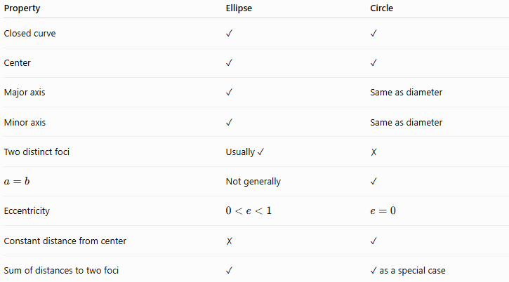
Property | Ellipse | Circle
Closed curve | ✓ | ✓
Center | ✓ | ✓
Major axis | ✓ | Same as diameter
Minor axis | ✓ | Same as diameter
Two distinct foci | Usually ✓ | ✗
$$a=b$$ | Not generally | ✓
Eccentricity | $$0<e<1$$ | $$e=0$$
Constant distance from center | ✗ | ✓
Sum of distances to two foci | ✓ | ✓ as a special case

Ellipse vs Oval
# Source: AI Source: Provided by: [Data Path: Persons Table -> ID Column: 1, Name_En Column: Motasem Essam] -> From: [ChatGPT] on [7/25/2026]
The terms ellipse and oval should not be treated as exact synonyms.
An ellipse is a specific mathematical curve satisfying a precise equation and focal property.
An oval is a broader descriptive term for a closed, rounded shape that resembles an egg or ellipse.
Therefore:
$$\boxed{\text{Every ellipse is oval-shaped, but not every oval is an ellipse}}$$

Classification in Geometric Construction
# Source: AI Source: Provided by: [Data Path: Persons Table -> ID Column: 1, Name_En Column: Motasem Essam] -> From: [ChatGPT] on [7/25/2026]
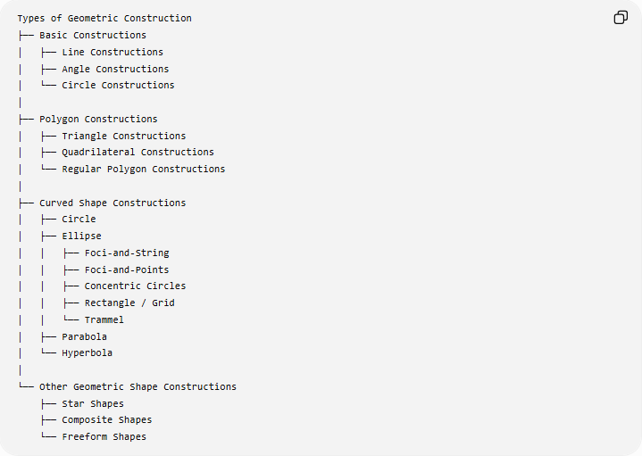
Types of Geometric Construction
├── Basic Constructions
│ ├── Line Constructions
│ ├── Angle Constructions
│ └── Circle Constructions
│
├── Polygon Constructions
│ ├── Triangle Constructions
│ ├── Quadrilateral Constructions
│ └── Regular Polygon Constructions
│
├── Curved Shape Constructions
│ ├── Circle
│ ├── Ellipse
│ │ ├── Foci-and-String
│ │ ├── Foci-and-Points
│ │ ├── Concentric Circles
│ │ ├── Rectangle / Grid
│ │ └── Trammel
│ ├── Parabola
│ └── Hyperbola
│
└── Other Geometric Shape Constructions
├── Star Shapes
├── Composite Shapes
└── Freeform Shapes

Key Points
# Source: AI Source: Provided by: [Data Path: Persons Table -> ID Column: 1, Name_En Column: Motasem Essam] -> From: [ChatGPT] on [7/25/2026]
- An ellipse is a closed curve defined by a constant sum of distances to two foci.
- Its fundamental focal property is:
$$\boxed{PF_{1}+PF_{2}=2a}$$
- Its major axis has length:
$$\boxed{2a}$$
- Its minor axis has length:
$$\boxed{2b}$$
- The focal distance satisfies:
$$\boxed{c^{2}=a^{2}-b^{2}}$$
- Its standard equation is:
$$\boxed{\frac{x^{2}}{a^{2}}+\frac{y^{2}}{b^{2}}=1}$$
- Its area is:
$$\boxed{A=πab}$$
- An ellipse can be constructed using:
  - foci and string;
  - foci and points;
  - major and minor axes;
  - concentric circles;
  - rectangle/grid methods;
  - a trammel.
- A circle is a special case of an ellipse when:
$$\boxed{a=b}$$

Conclusion
# Source: AI Source: Provided by: [Data Path: Persons Table -> ID Column: 1, Name_En Column: Motasem Essam] -> From: [ChatGPT] on [7/25/2026]
An ellipse is a precisely defined curved geometric shape characterized by two foci and a constant sum of distances to those foci. It can be constructed in several ways, including the foci-and-string method, foci-and-points method, concentric circles method, rectangle/grid method, and trammel method. The major and minor axes determine its size and shape, while the relationship
$$\boxed{a^{2}=b^{2}+c^{2}}$$
connects its semi-axes with its focal distance.

